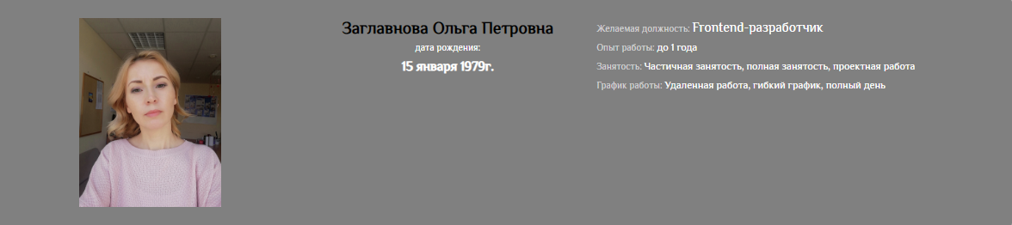

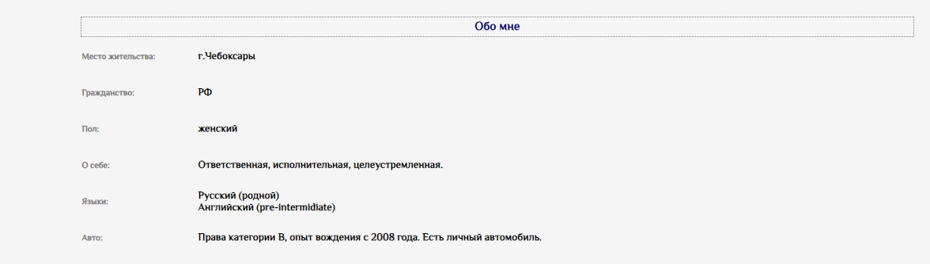

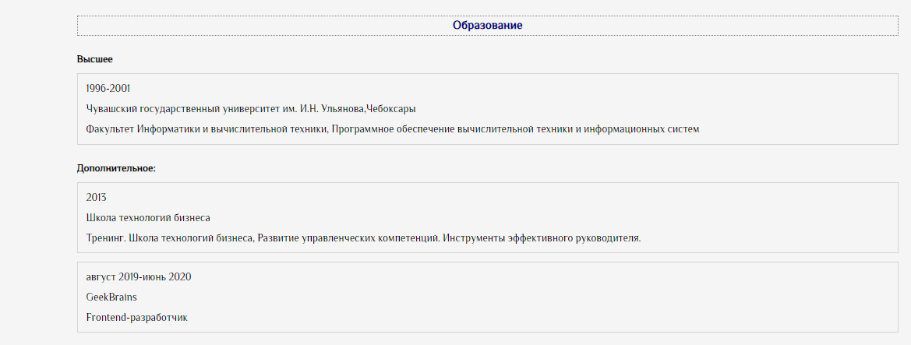



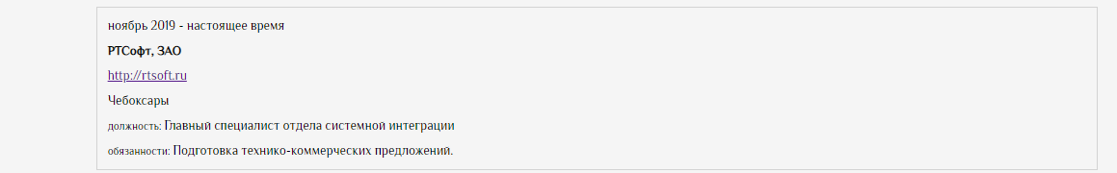

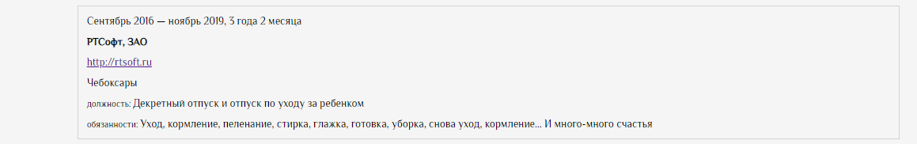

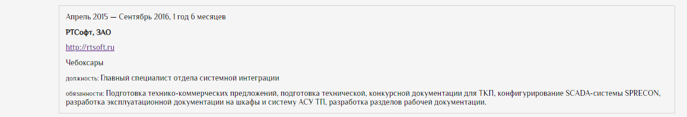

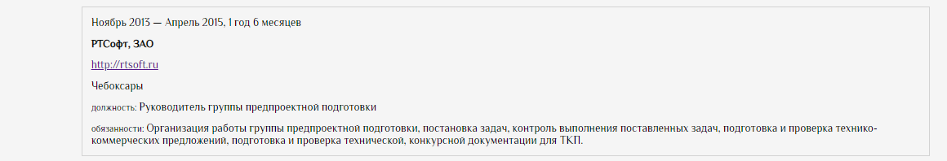

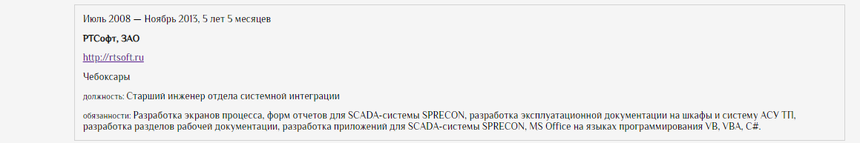

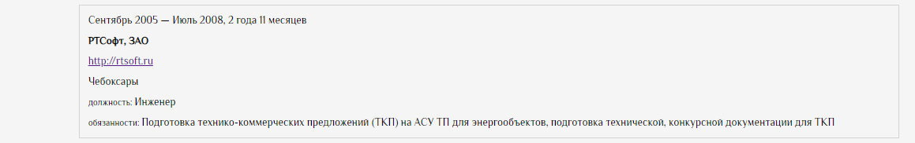

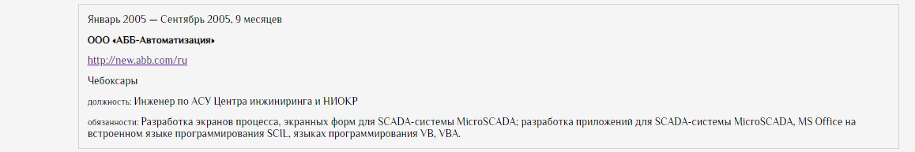

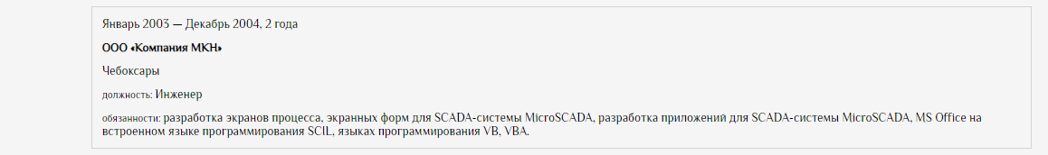

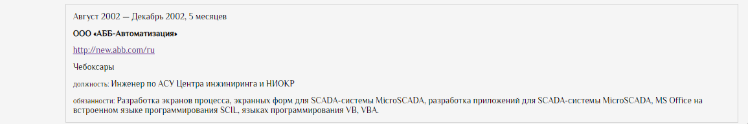

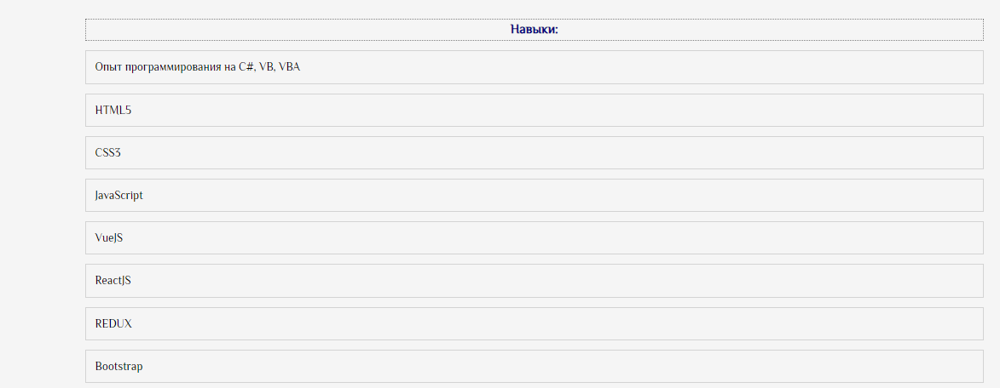





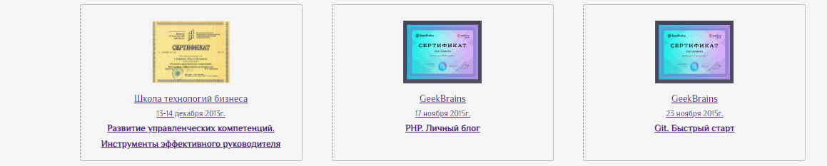

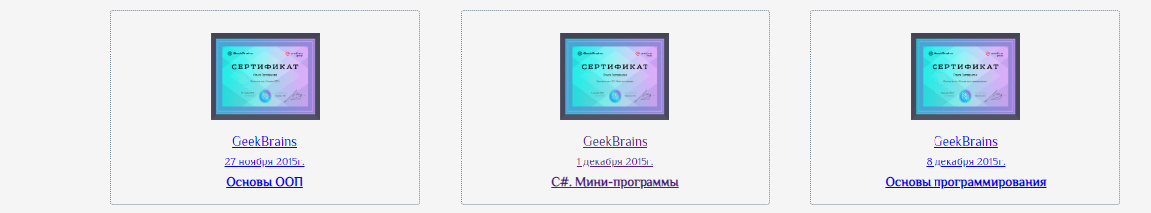

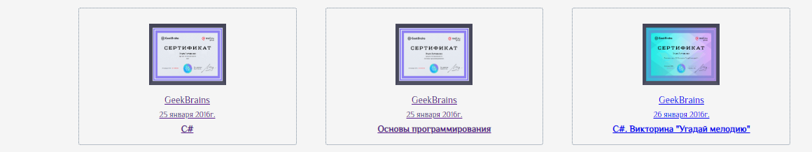

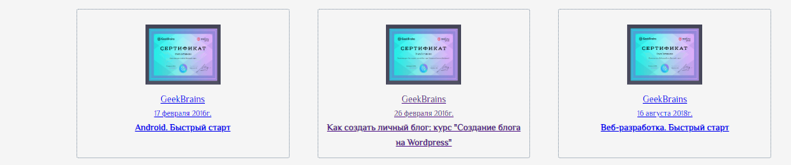

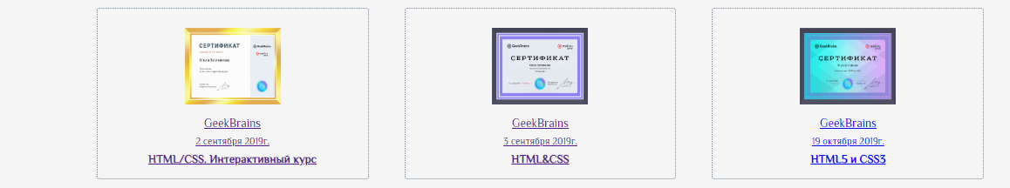

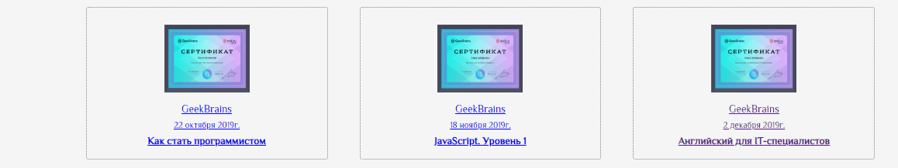

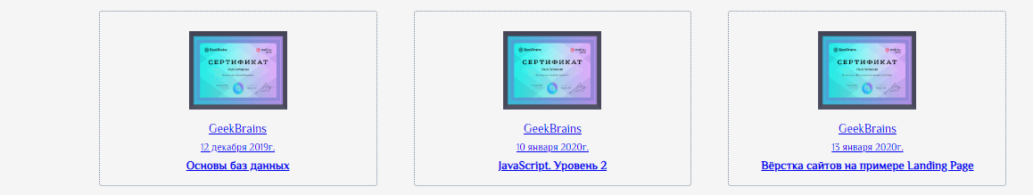

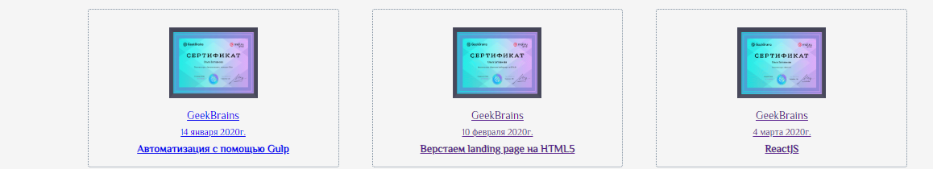



|  |  |
| --- | --- |
|  | +7(905)-346-52-75 |
|  | olga.zaglavnova@mail.ru |
|  | smirnova.olga.1979 |